Olusegun Afolabi
EECE 412
Prof Wenjie

Introduction
The objective of Lab 12 was to extend the existing Pong Game Starter by implementing a firing mechanism. The player now controls a spaceship (modified paddle) that can launch a missile (ball) horizontally across the screen. This lab introduces animation, bitmap rendering, conditional launching, and projectile motion using a firing button.

Steps and Implementation
1. Project Setup
- A new Vivado project was created based on the existing Pong framework.
- The source file lab12_Afolabi_pong_graph_st.vhd was created and added to the project.
- The .xdc constraints file was updated to include BTN4 for firing control, along with existing paddle movement buttons.
2. Shape Definition and Display
- A spaceship was defined using a 16x16 ROM bit-map.
- Drawing logic compares the current pixel_x and pixel_y values to the bounding box of the spaceship.
- A ROM lookup determines whether a pixel should be drawn.
- The spaceship is rendered using a blue color (graph_rgb <= "001").
3. Missile Launch Logic
- A missile (firing ball) object was introduced with a 4x4 bounding box.
- A missile launch occurs only when:
  - BTN4 is pressed.
  - The previous missile has exited the screen (single shot).
- The missile spawns at the center of the spaceship and moves horizontally left across the screen on each refresh cycle.
4. Object Movement
- Movement control uses refr_tick, which triggers at each vertical screen refresh (60 Hz).
- Each refresh decrements the missile’s x position by a constant speed (BALL_V := 4).
- If the missile is not fired or moves off-screen, it remains hidden.
Code:
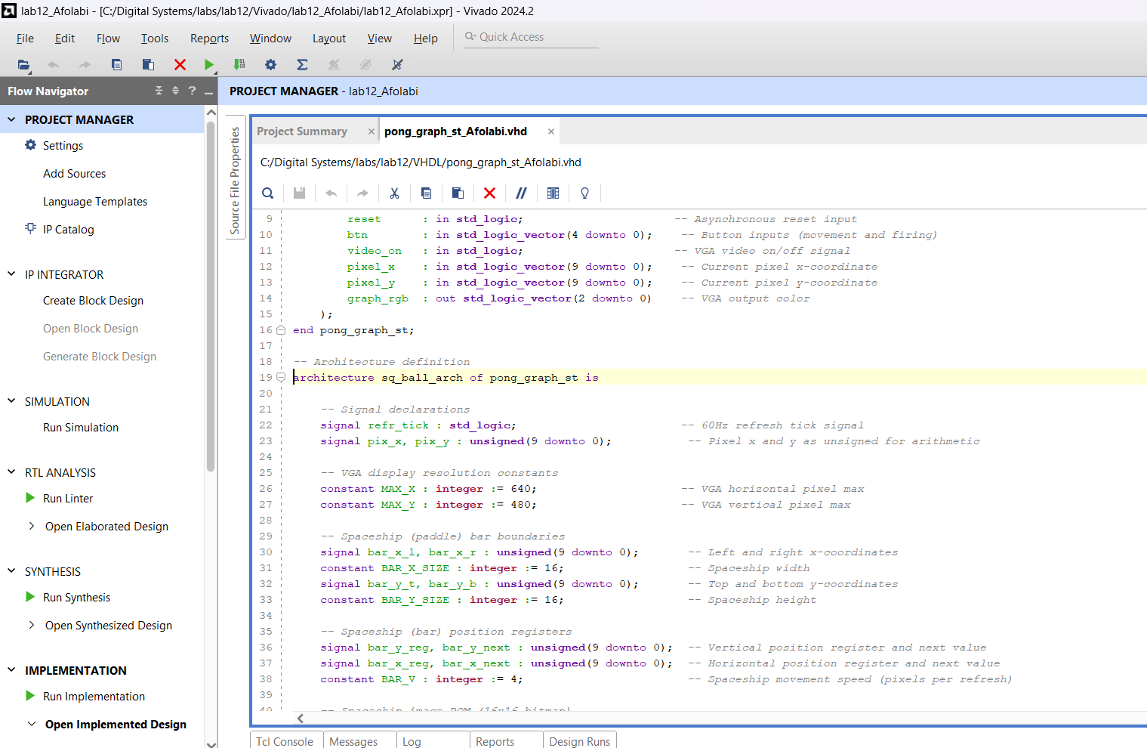
Lab Results
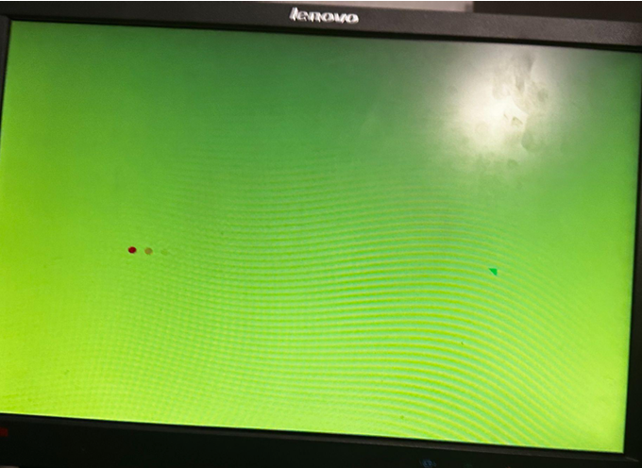

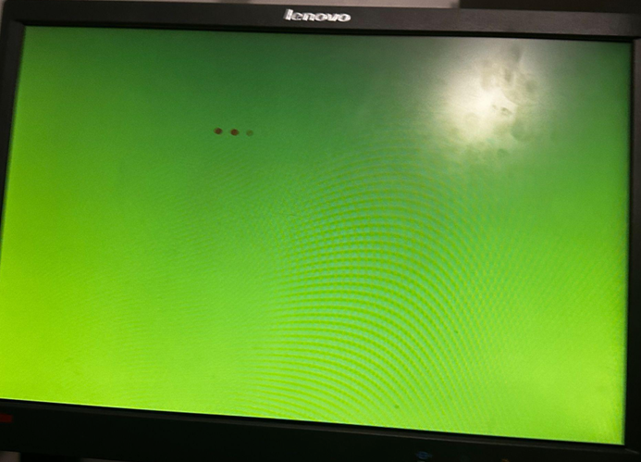
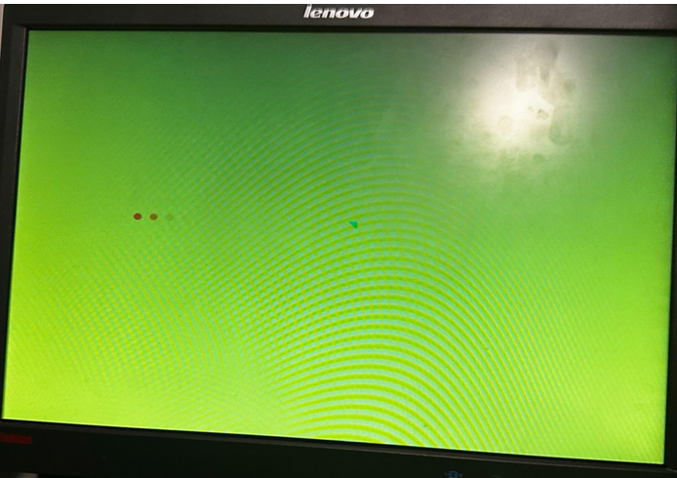

3a. 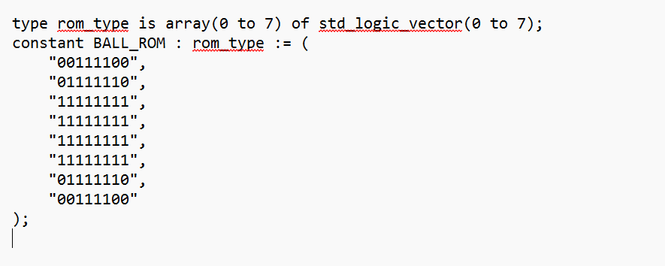
The firing ball was defined using a custom 8x8 bitmap ROM

4a. 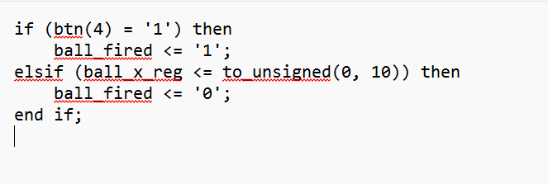
Launch control checks the fire button and resets missile firing when the ball moves off-screen
4b. 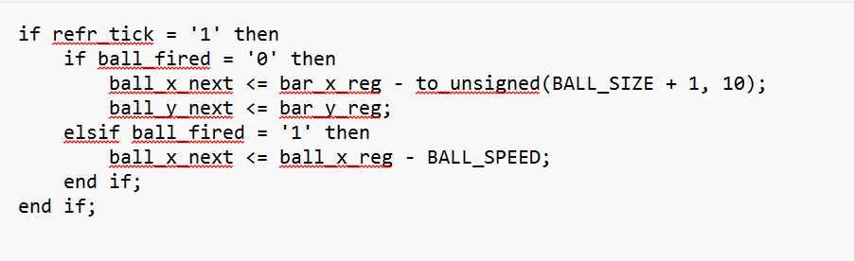
When the missile is not fired, it tracks the spaceship center. When fired, it continuously moves left at a fixed speed.
4c. Bounding logic for the missile is handled as: 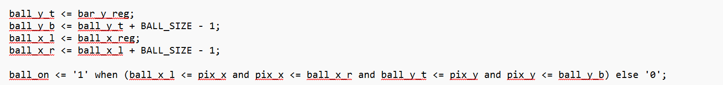
ROM mapping to draw the pixel:
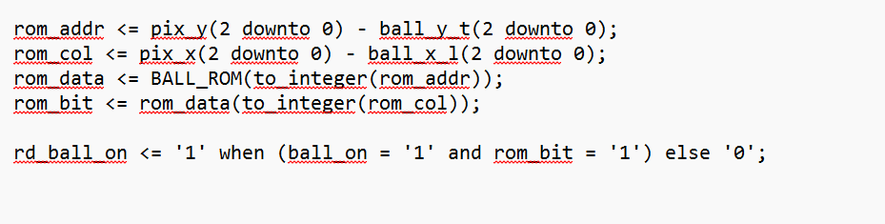
4d. 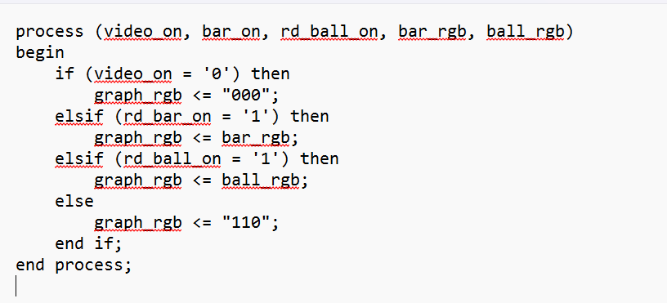
When the missile pixel is active (rd_ball_on = '1'), it is drawn on top. Otherwise, the spaceship or background is shown depending on pixel conditions.

Conclusion
Lab 12 successfully introduced a firing ball projectile system into the Pong-based VGA game framework. Through bitmap shape definitions, button-triggered movement, and screen-based object tracking, the lab demonstrated advanced control of graphics at the pixel level. These skills are foundational for future projects involving real-time object dynamics, embedded game development, and FPGA-based graphics systems.

